Functional & Performance Testing Template
Model Performance Test

Date | 08 October 2026
Team ID | 9100Byte
Project Name | Implement Client Script & UI Policy (Incident)
Maximum Marks | As per evaluation

Test Scenarios & Results
Test Case ID | Scenario (What to test) | Test Steps (How to test) | Expected Result | Actual Result | Pass/Fail
FT-01 | UI Policy – High Impact | Open Incident; set Impact to High. | Assignment group becomes mandatory and Urgency is read-only. | PASS – Supplied screenshot/documentation shows the High Impact UI Policy configuration. | PASS
FT-02 | Automatic Urgency Update | Change Impact to High. | Urgency is automatically set to High and an informational message is displayed. | PASS – Supplied implementation documents the automatic Urgency update to High. | PASS
FT-03 | Save Validation | Set Impact High; leave Assigned To blank; save. | Save is blocked and an error is shown for Assigned To. | PASS – Supplied implementation documents save blocking and the Assigned To error. | PASS
FT-04 | Valid High Impact Save | Set Impact High; select Assigned To; save. | Incident saves successfully. | PASS – Supplied validation flow supports successful save when Assigned To is provided. | PASS
FT-05 | Condition Reversal | Change Impact from High to Medium. | Assignment group is no longer mandatory and Urgency becomes editable. | PASS – Supplied implementation documents Reverse if false restoration. | PASS
FT-06 | List Edit Restriction | Edit State directly from Incident list. | Change is rejected and original State remains unchanged. | PASS – Supplied implementation screenshot/evidence shows list editing protection. | PASS
PT-01 | Client-side Response | Change Impact between values and observe rule response. | UI Policy and onChange behavior should respond immediately. | PASS – Client-side rule response is configured for Impact changes. | PASS
PT-02 | Save Validation Response | Attempt save with missing Assigned To under High Impact. | Validation executes during save and prevents submission. | PASS – Save-time validation is configured for the stated condition. | PASS
PT-03 | List Editing Response | Attempt multiple direct State edits from list view. | Each restricted edit is rejected consistently. | PASS – Direct State list edits are configured to be rejected. | PASS

Evidence screenshots are retained from the supplied implementation document. They demonstrate the configured ServiceNow screens and scripts; PASS is recorded as documented implementation evidence, not as a newly executed live test.
Functional / Performance Evidence
Evidence: Supplied ServiceNow implementation screenshot(s).
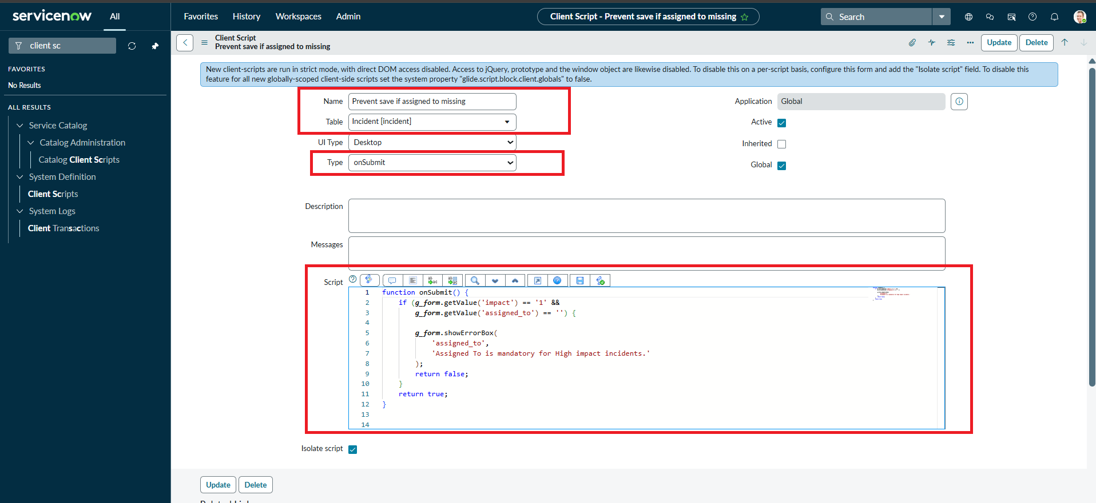
image7.png
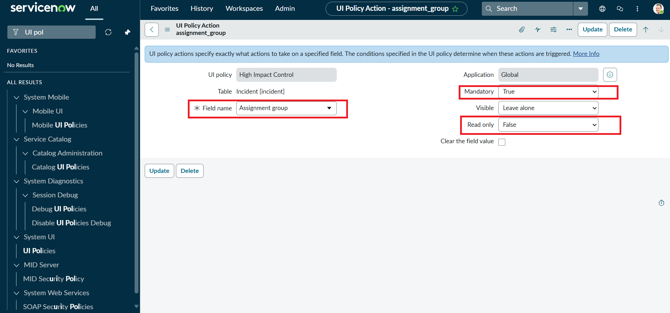
image3.png
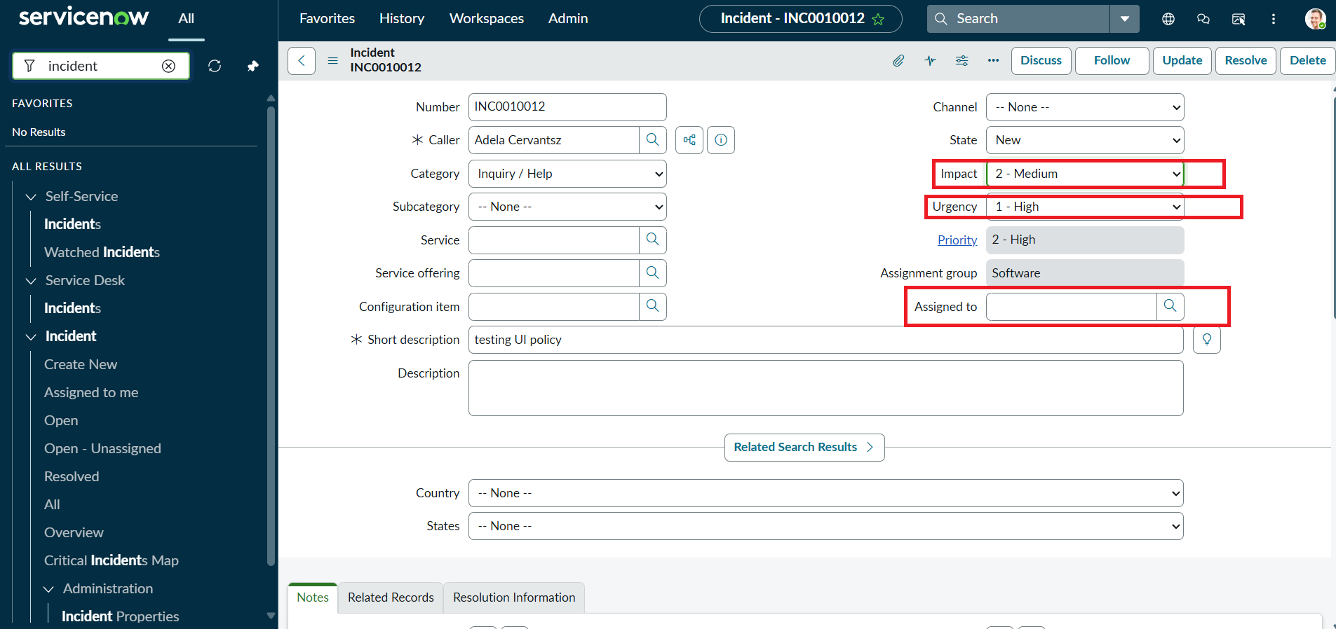
image12.png
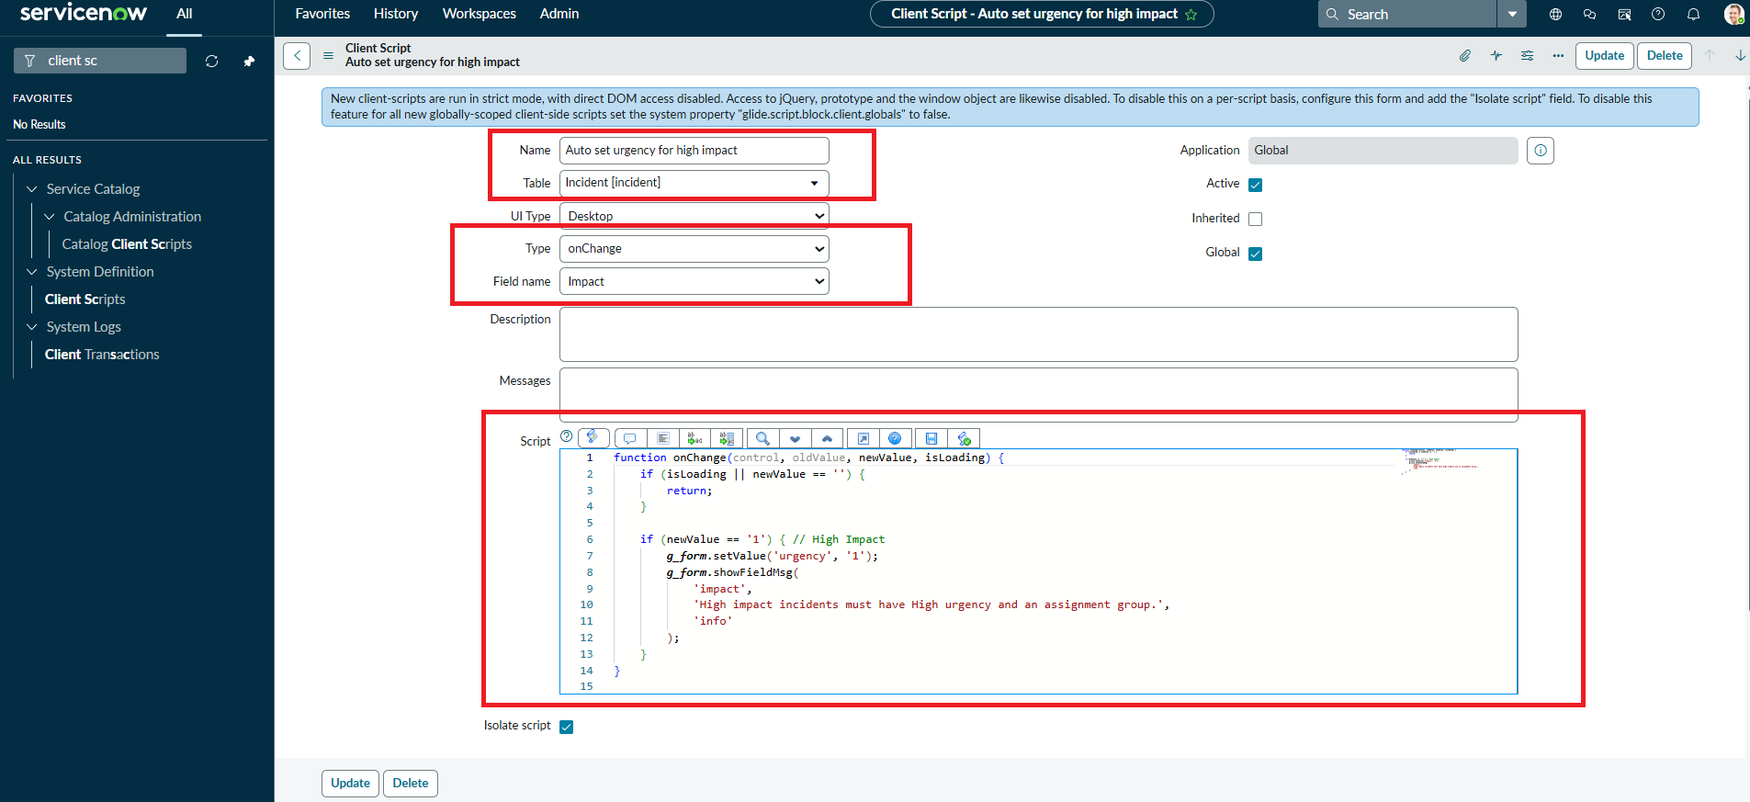
image6.png
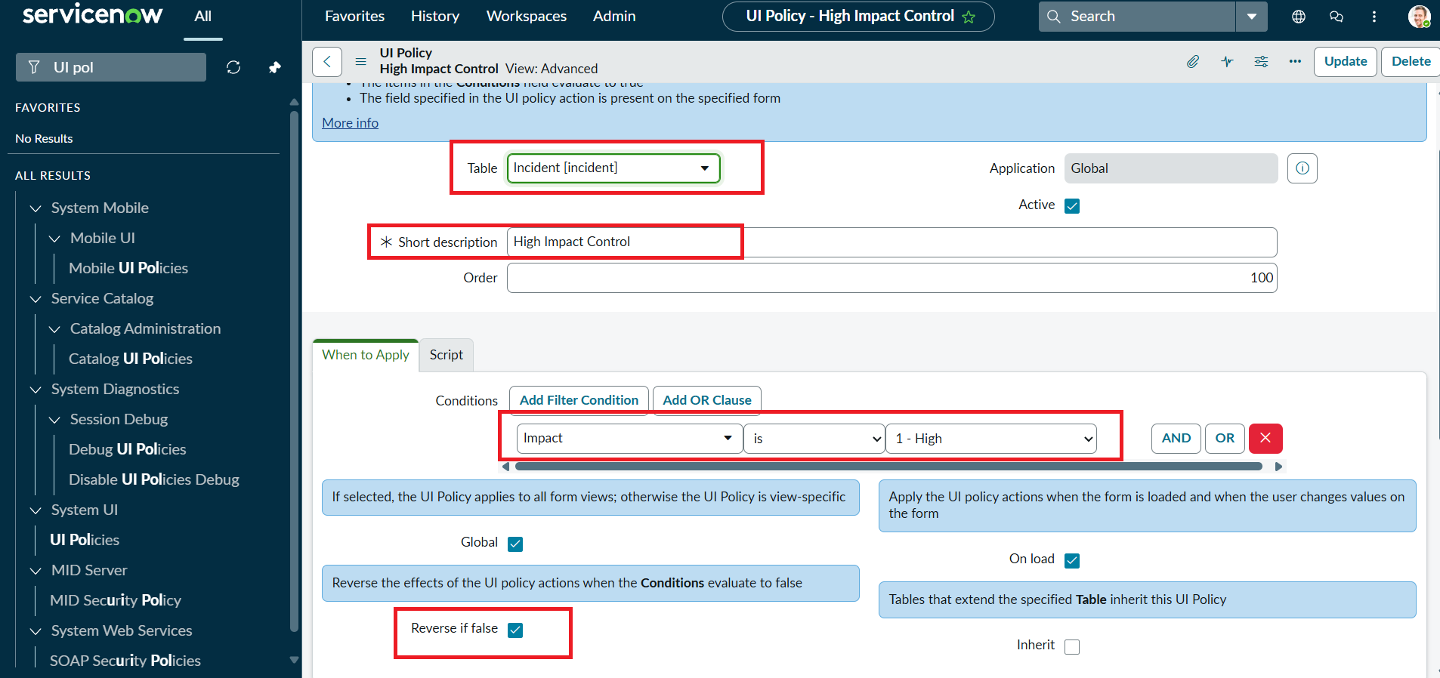
image2.png
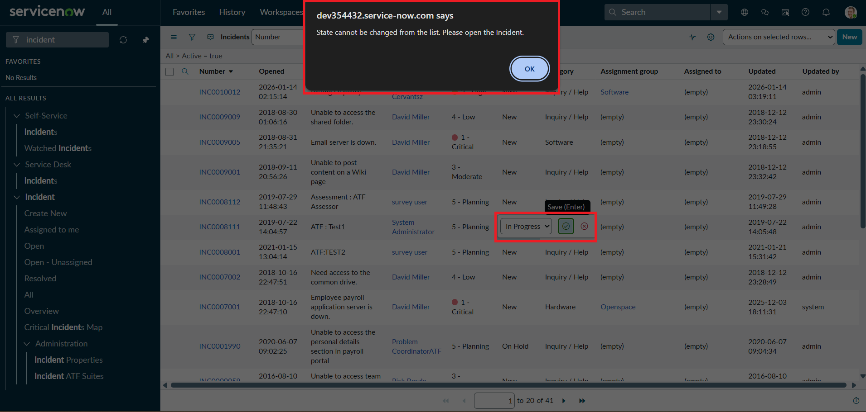
image14.png

